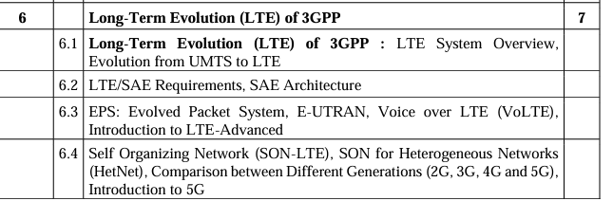

-> SAE Architecture and Requirements

-> VOLTE

->EPC/ EPS (Evolved Packet System)

-> SON – LTE

-> 2G vs 3G vs 4G vs 5G

-> Short note on 5G technology

### 5G Technology: A Brief Overview

5G technology, the fifth generation of mobile networks, represents a significant leap forward from previous generations, offering unprecedented speed, capacity, and connectivity. It aims to meet the growing demand for data and connectivity in an increasingly digital world. Here are the key aspects of 5G technology:

#### Key Features and Improvements

1. **Enhanced Speed and Bandwidth**:

- **Data Rates**: 5G networks can achieve data rates of up to 10 Gbps, which is 10 to 100 times faster than 4G networks. This supports high-definition video streaming, virtual reality, and augmented reality applications.

- **Bandwidth**: With the use of wider frequency bands, including mmWave (millimeter wave) spectrum, 5G offers significantly greater bandwidth, allowing more data to be transmitted simultaneously.

2. **Low Latency**:

- **Latency**: 5G aims to reduce latency to as low as 1 millisecond, enabling real-time applications such as remote surgery, autonomous driving, and gaming.

3. **Increased Capacity and Connectivity**:

- **Massive IoT**: 5G is designed to connect a massive number of devices per square kilometer, supporting the Internet of Things (IoT) with up to 1 million devices per square kilometer.

- **Enhanced Mobile Broadband (eMBB)**: Provides high-speed internet access for mobile users, supporting data-intensive applications and services.

4. **Reliability and Availability**:

- **Ultra-Reliable Low Latency Communication (URLLC)**: Ensures high reliability and low latency for critical applications, such as industrial automation and public safety.

- **Network Slicing**: Allows the creation of multiple virtual networks within a single physical 5G network, each tailored to specific use cases and requirements.

#### Components of 5G Technology

1. **New Radio (NR) Interface**:

- **NR**: The new global standard for 5G wireless communication, designed to work across a wide range of frequencies, from sub-1 GHz to mmWave spectrum.

- **Beamforming**: Uses advanced antenna technology to direct signals precisely towards the receiver, improving signal strength and reducing interference.

2. **5G Core Network**:

- **Architecture**: A cloud-native, service-based architecture that supports flexible deployment and efficient network management.

- **Edge Computing**: Brings computational capabilities closer to the end-user, reducing latency and improving performance for time-sensitive applications.

#### Applications of 5G Technology

1. **Enhanced Mobile Broadband (eMBB)**:

- **Use Cases**: High-speed internet access, HD video streaming, virtual reality (VR), and augmented reality (AR).

2. **Massive IoT**:

- **Use Cases**: Smart cities, connected homes, industrial IoT, environmental monitoring, and health monitoring devices.

3. **Ultra-Reliable Low Latency Communication (URLLC)**:

- **Use Cases**: Autonomous vehicles, remote surgery, industrial automation, and mission-critical communications.

#### Benefits of 5G Technology

- **Speed and Efficiency**: Faster download and upload speeds enhance user experience and productivity.

- **Capacity and Connectivity**: Supports more devices and higher data volumes, essential for IoT and smart applications.

- **Innovation and Economic Growth**: Enables new services and business models, fostering innovation and driving economic growth.

#### Challenges and Considerations

- **Infrastructure Investment**: Requires significant investment in new infrastructure, including base stations and fiber-optic networks.

- **Spectrum Availability**: Efficient use of available spectrum and allocation of new spectrum bands are crucial for optimal performance.

- **Security and Privacy**: Ensuring robust security measures to protect against cyber threats and safeguarding user privacy are paramount.

### Conclusion

5G technology is set to revolutionize mobile communication by providing higher speeds, lower latency, and greater capacity. It will enable a wide range of new applications and services, driving innovation across various sectors. Despite the challenges in deployment and infrastructure, the benefits of 5G are expected to significantly impact society and the global economy.

IMPORTANT QUESTIONS:

Q. Explain in short voice over LTE || Q. Explain in short voice over LTE – 5M x2

**Q.10 Write short notes on VoLTE.** 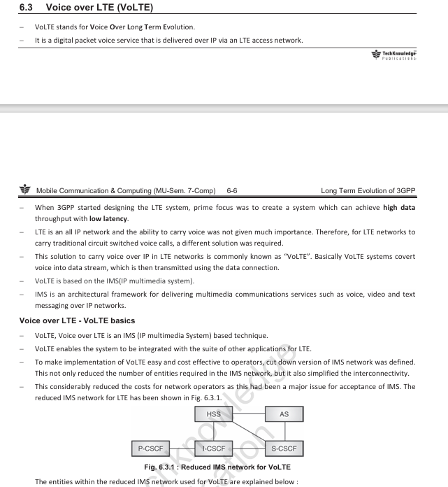

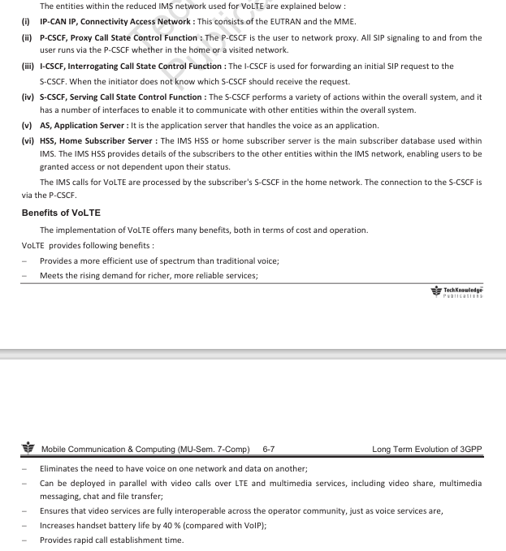

Voice over Long-Term Evolution (VoLTE) is a technology standard for delivering voice communication and multimedia services over 4G LTE networks. Here are some key points about VoLTE:

1. **Enhanced Voice Quality**: VoLTE offers higher-quality voice calls compared to traditional circuit-switched voice calls. It leverages the wideband audio codec (e.g., Adaptive Multi-Rate Wideband, or AMR-WB) to deliver HD voice quality, resulting in clearer and more natural-sounding conversations.

2. **Improved Call Setup Time**: VoLTE significantly reduces call setup time compared to traditional voice calls over 2G or 3G networks. Calls are established more quickly due to the use of IP-based signaling and media transmission, leading to faster call initiation and reduced latency.

3. **Simultaneous Voice and Data**: One of the notable features of VoLTE is the ability to make voice calls while simultaneously using data services over LTE. This contrasts with older technologies where voice calls would drop down to 2G or 3G networks, interrupting data services.

4. **Efficient Spectrum Utilization**: VoLTE utilizes packet-switched technology over LTE networks, optimizing spectrum usage and increasing network capacity. This efficiency allows operators to support more voice calls and data traffic within the same bandwidth, leading to improved network performance and user experience.

5. **Rich Multimedia Services**: In addition to voice calls, VoLTE supports a wide range of multimedia services, including video calling (ViLTE), multimedia messaging (MMS), and rich communication services (RCS). These services enable users to engage in more immersive and interactive communication experiences.

6. **Interoperability and Roaming**: VoLTE supports seamless interoperability and roaming across different LTE networks and operators. This ensures that users can access VoLTE services regardless of their location or the network they are connected to, enhancing connectivity and accessibility.

7. **Deployment Challenges**: While VoLTE offers numerous benefits, its deployment requires network infrastructure upgrades and device support. Operators need to ensure that their LTE networks are VoLTE-capable, and users must have VoLTE-compatible devices to access the service.

Overall, VoLTE represents a significant advancement in voice communication technology, offering enhanced voice quality, faster call setup times, simultaneous voice and data services, and support for rich multimedia communication. As LTE networks continue to evolve and expand, VoLTE is expected to become the standard for voice communication in the mobile industry

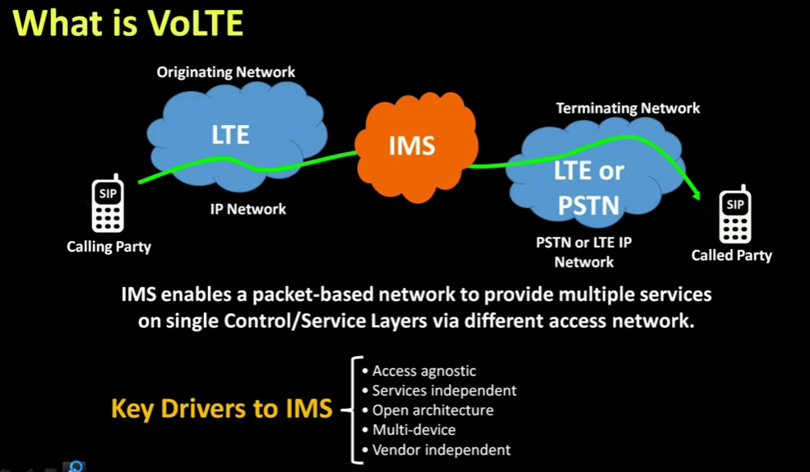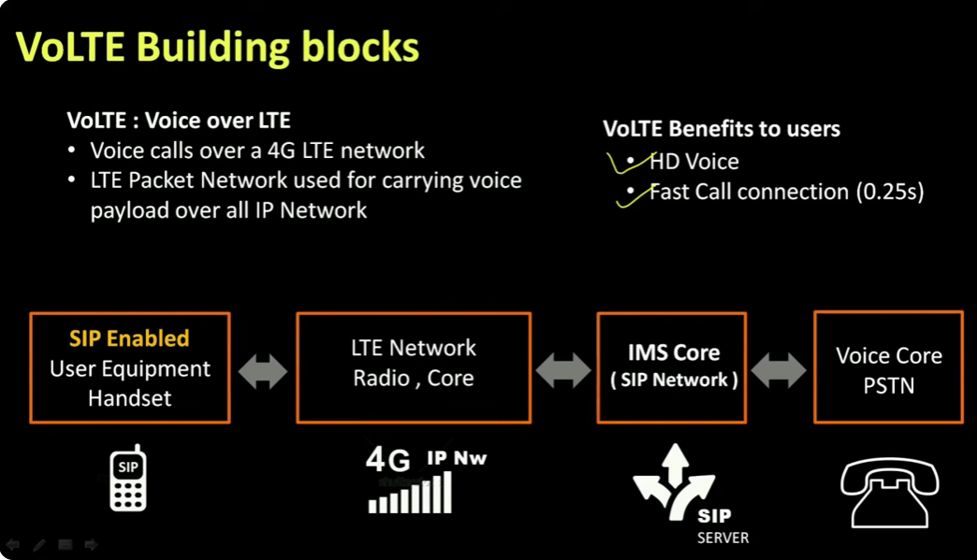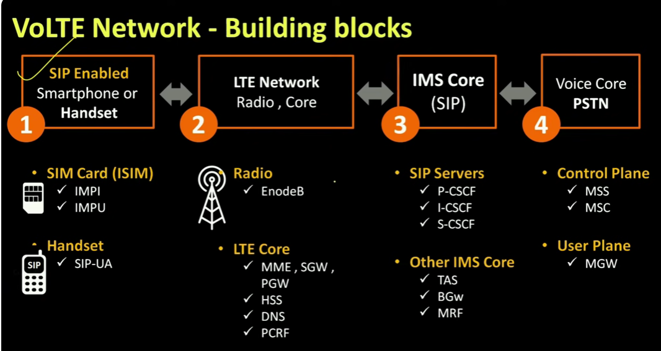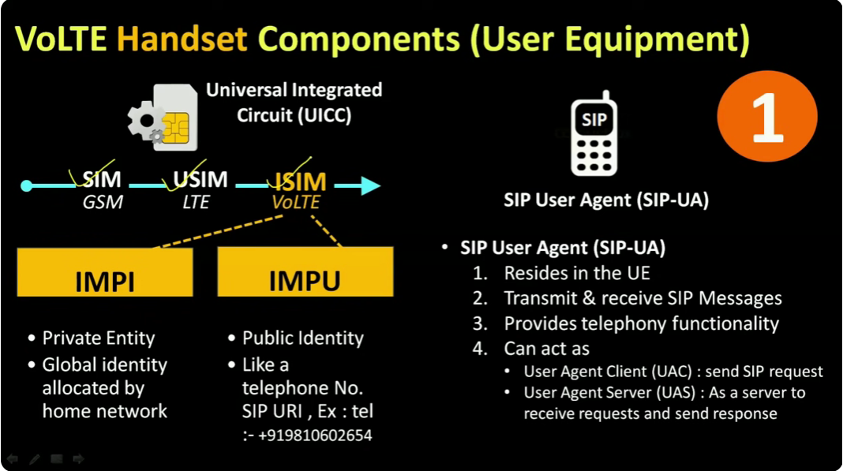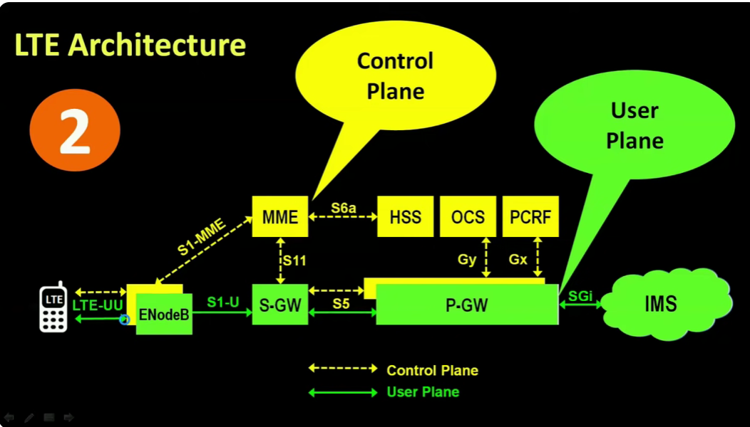

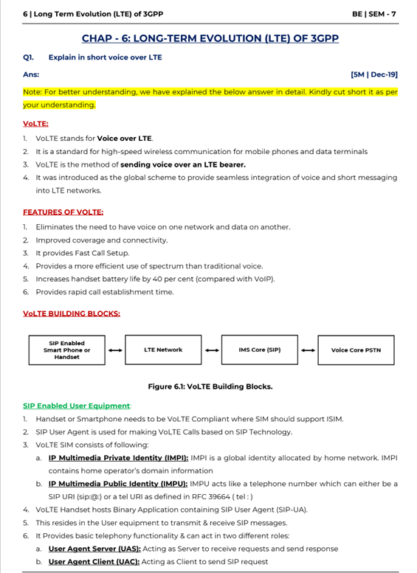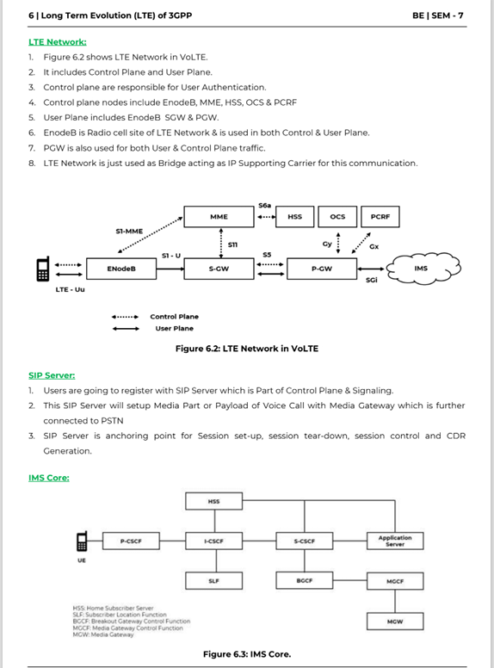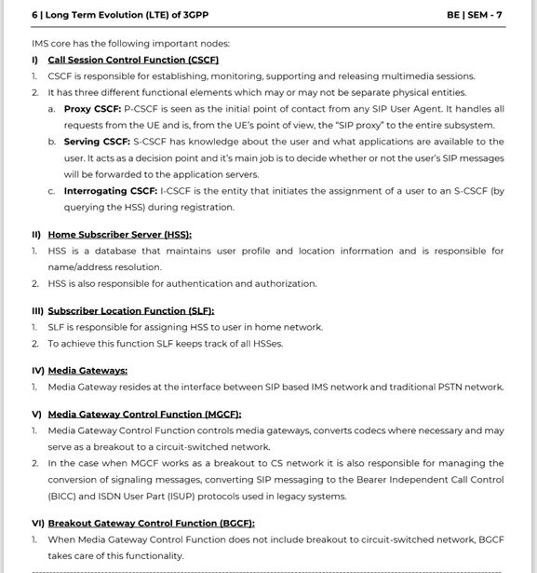

Q. Compare various telecommunication generations || Q. Compare various telecommunication generations – 5M

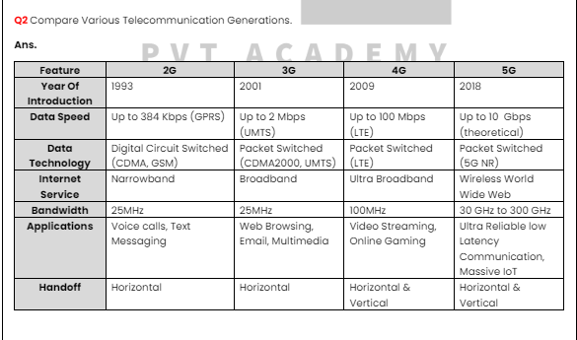

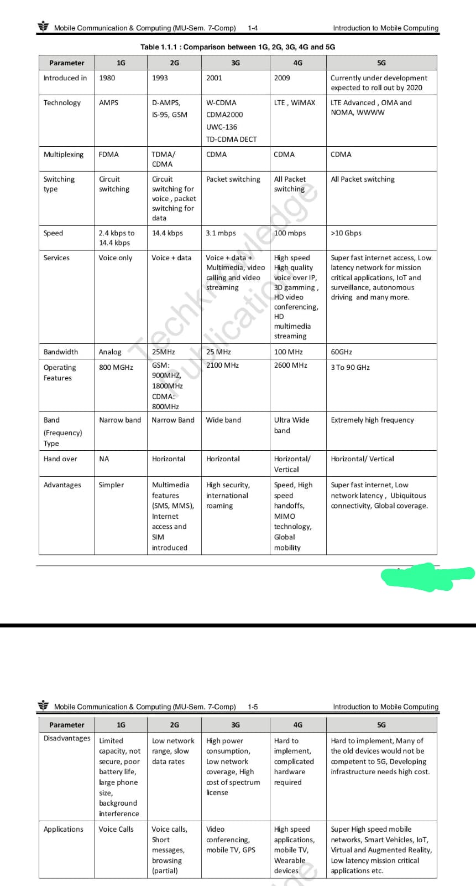 Q. Explain different components used in LTE architecture w diagram – 10M X2

Q. Explain various nodes present in E-UTRAN architecture – 10M

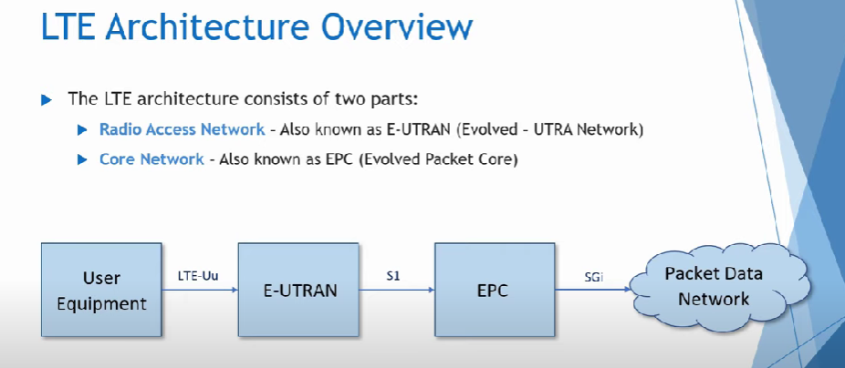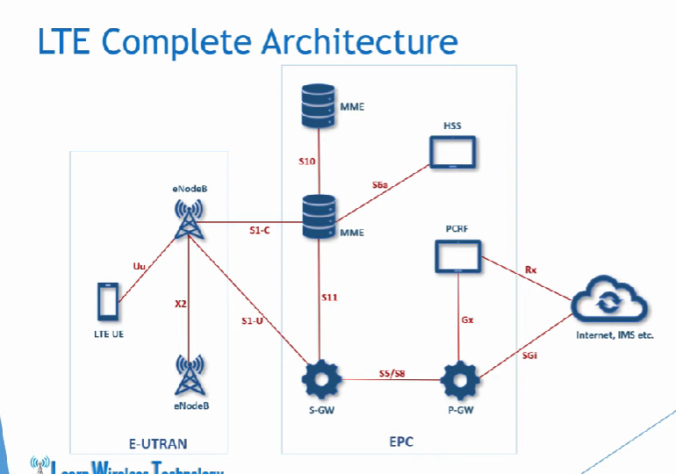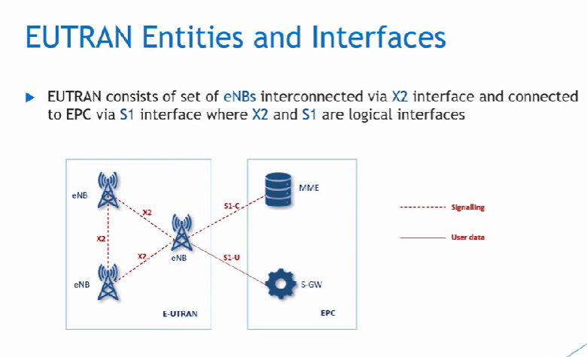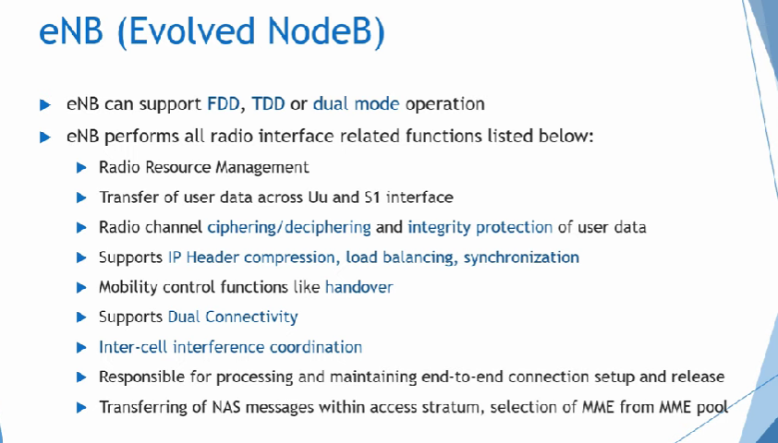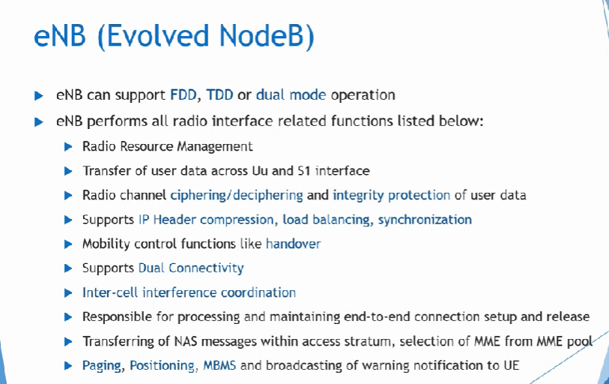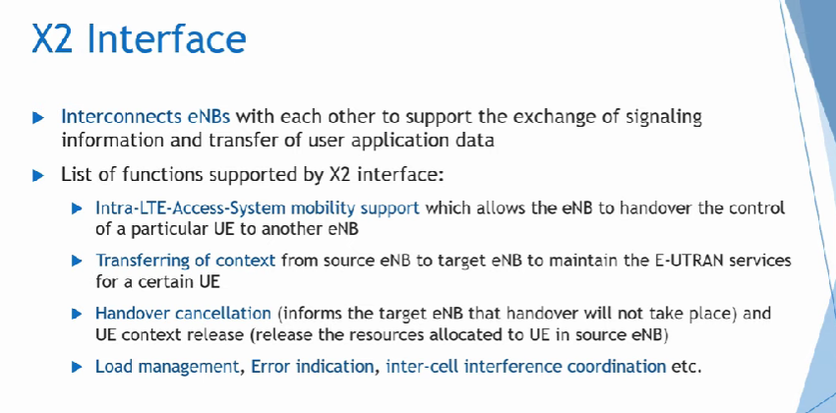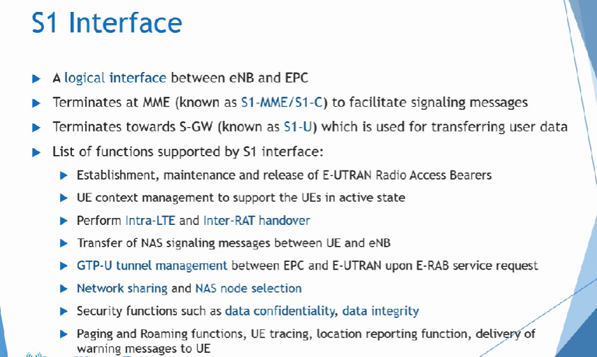

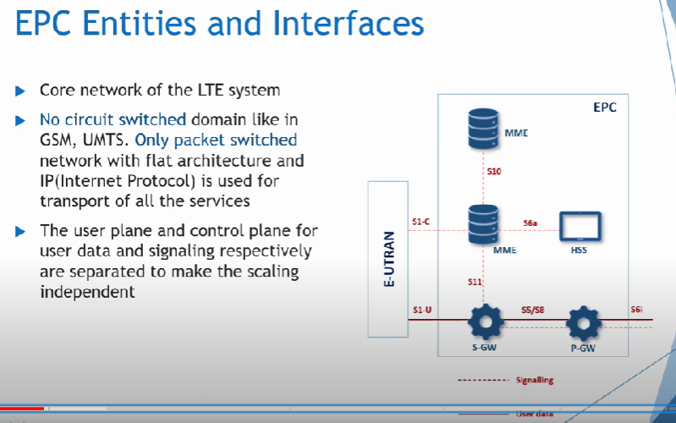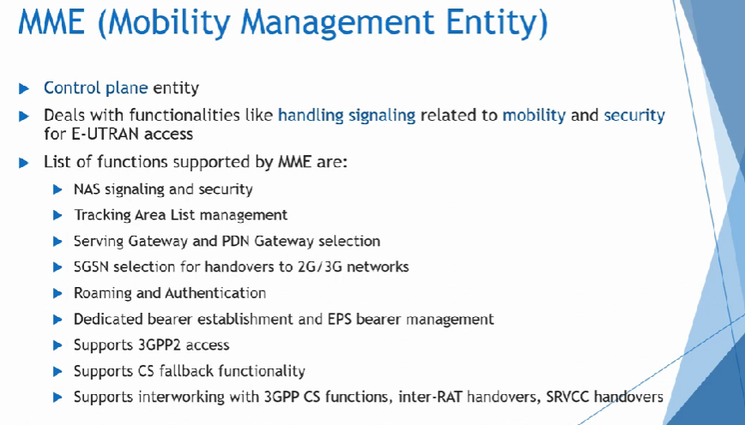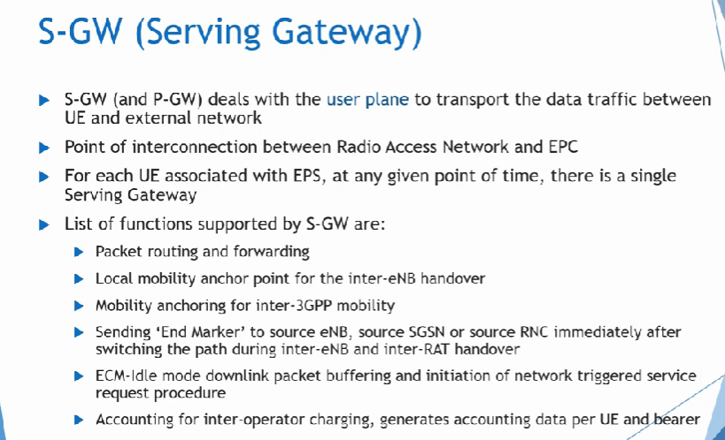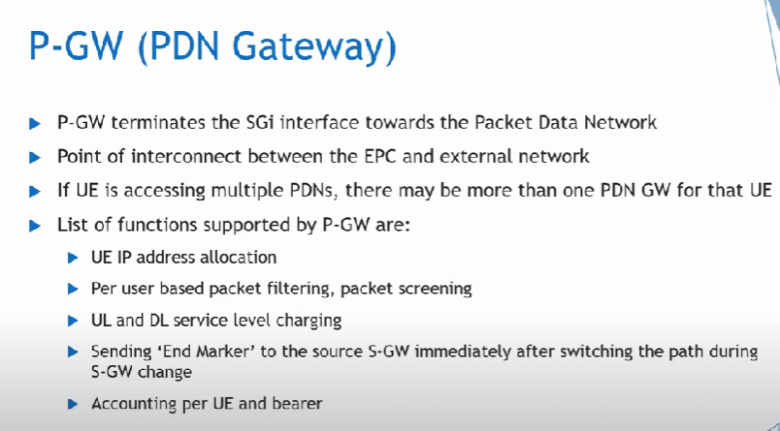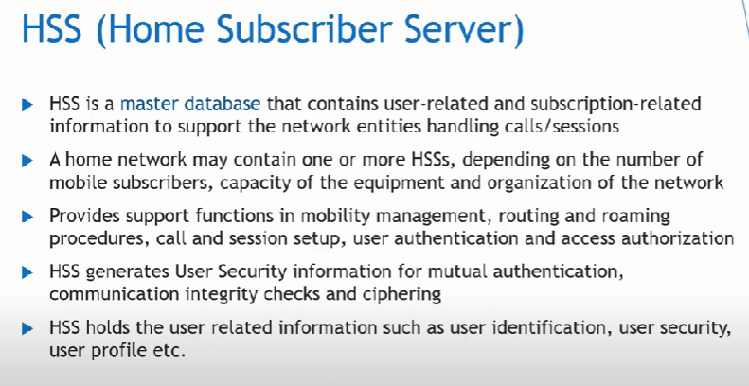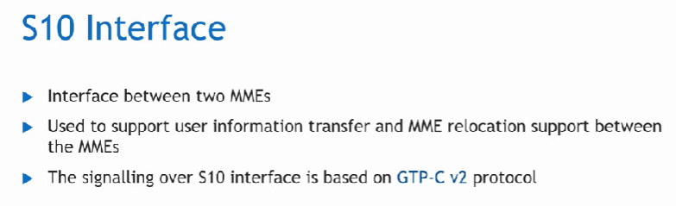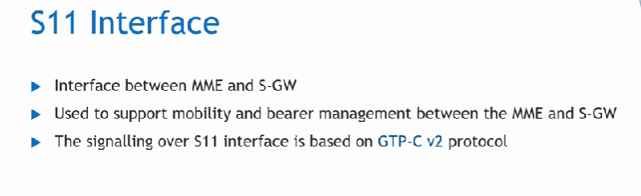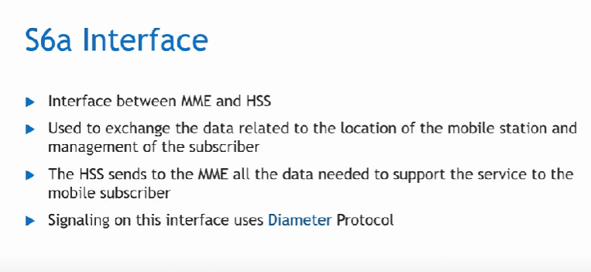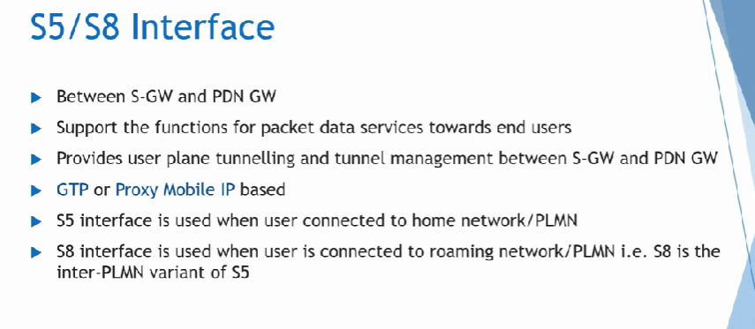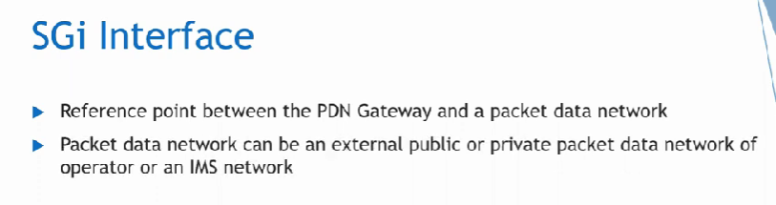LTE Architecture

The high-level network architecture of LTE is composed of the following three key components:

1. The User Equipment (UE).
2. The Evolved UMTS Terrestrial Radio Access Network (E-UTRAN).
3. The Evolved Packet Core (EPC).

An improved packet core communicates with packet data networks such as the internet, a company’s private network or the IP multimedia subsystem. The interfaces between the different parts of the system are denoted Uu, S1, and SGi as shown below:

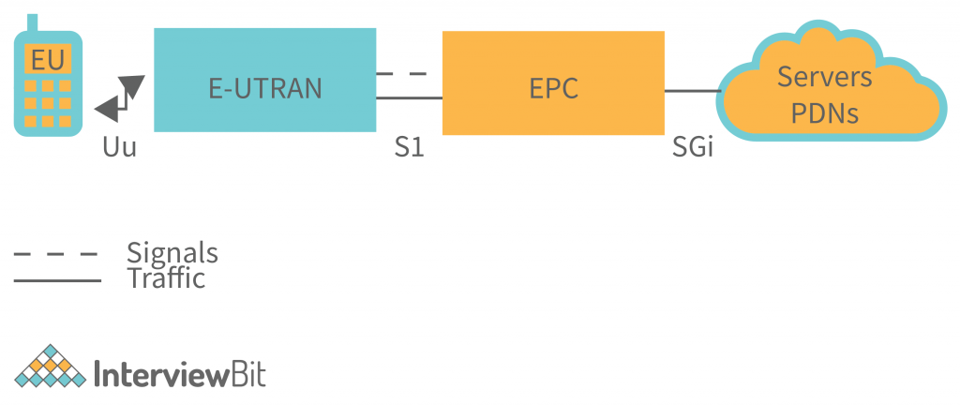

### User Equipment (UE)

The internal architecture of the user equipment for LTE is exactly the same as that of UMTS and GSM, which is mobile equipment (ME). The mobile equipment has the following core modules:

1. All communication functions are handled by Mobile Termination (MT).
2. The data streams are terminated in Terminal Equipment (TE).
3. The SIM card for LTE equipment is known as the Universal Integrated Circuit Card (UICC). This application is known as the Universal Subscriber Identity Module (USIM).

The information stored on a USIM card is similar to that of a 3G SIM card, including the user’s telephone number, home network identity, and security keys.

### The E-UTRAN (The Access network) - An instance of the evolution of a UMTS Terrestrial Radio Access Network (E-UTRAN) architecture has been illustrated below.

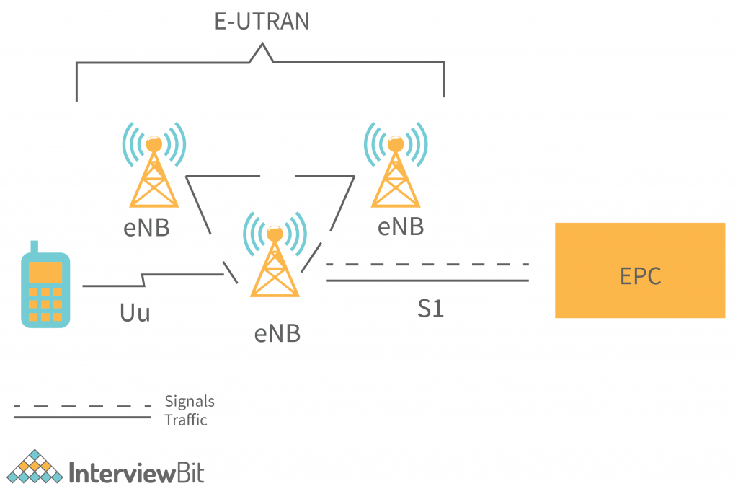

An evolved packet core or ePC controls the various information packets that are sent between mobile devices and the core network. In contrast to an eNB, which is a base station that controls mobile devices in one or more cells, an eNodeB controls radio communication between an evolved packet core or ePC and mobile devices.

An eNB can perform two main functions when connected to an LTE mobile device:

* The eBN sends and receives radio signals to and from all the mobile devices using the analogue and digital signal processing functions of the LTE air interface.
* The eNB sends handover commands to all of its mobiles at a low level, controlling their operation.

The EPC allows each eBN to be connected to the S1 interface of nearby base stations and the X2 interface for signalling and packet forwarding during handover, but it can also be connected to them via the S1 interface.

A home eNB (HeNB) is a user-owned base station for providing femtocell coverage in the home. A home eNB is part of a closed subscriber group (CSG) and may only be reached by mobile phones with a USIM that also belongs to the CSG.

### The Evolved Packet Core (EPC) (The core network)

The architecture of the Evolved Packet Core (EPC) has been revealed in the diagram. Besides, a few elements have not been shown in the diagram for simplicity reasons. The Earthquake and Tsunami Warning System (ETWS), Equipment Identity Register (EIR) and Policy Control and Charging Rules Function (PCRF) are examples of these components.

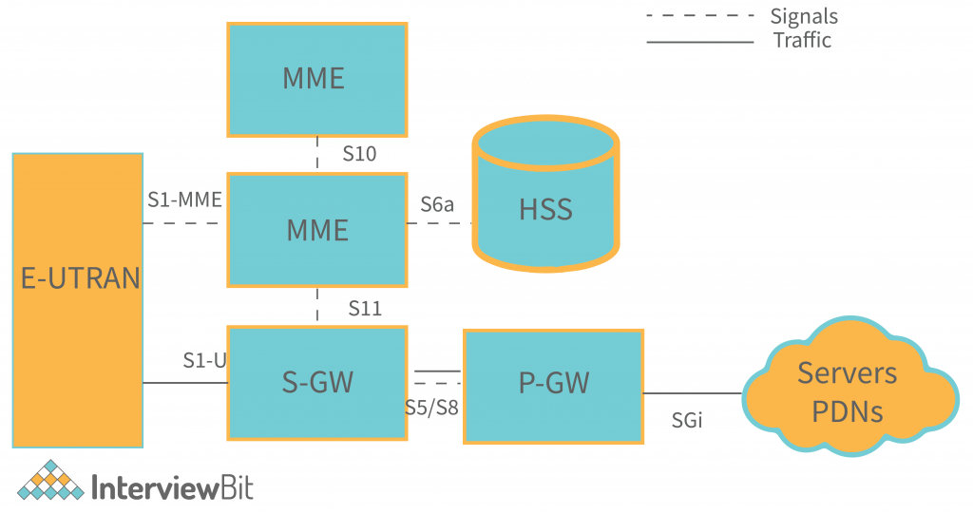

The components shown in the above architecture are listed below, with a brief description.

* The central database that contains information about all the network operator’s subscribers is known as the Home Subscriber Server (HSS). This information is carried over from UMTS and GSM and is located in the Home Subscriber Server (HSS) component.
* SGi is used to communicate with the outside world, i.e. packet data networks PDN, in which the P-GW is located. An APN is used to identify each packet data network. In addition to functioning as a GPRS support node (GGSN) and a serving GPRS support node (SGSN) for UMTS and GSM, the P-GW is comparable to the GSN and SGSN in packet data networks.
* The S-GW acts as a router between the base station and the PDN gateway, handling data forwarding.
* A mobile network operator’s (MNO) highest level control entity, the Home Subscriber Server (HSS), controls the mobile’s high-level operation through signalling messages.
* The PCEF (Policy Control Enforcement Function) is a component that is obscured in the above diagram, but it controls policy control decision-making as well as policy control charging functionality in the P-GW. The PCRF (Policy Control and Charging Rules Function) is a portion of the PCEF that controls policy control charging functionality.

When the two devices are on the same network, S5/S8 is used to communicate between the serving and PDN gateways. Which of the two interfaces is used, S5 or S8 depends on the network configuration.

Functional split between the E-UTRAN and the EPC - The graphical explanation provides an overview of the splits between the E-UTRAN and the EPC in an LTE network.

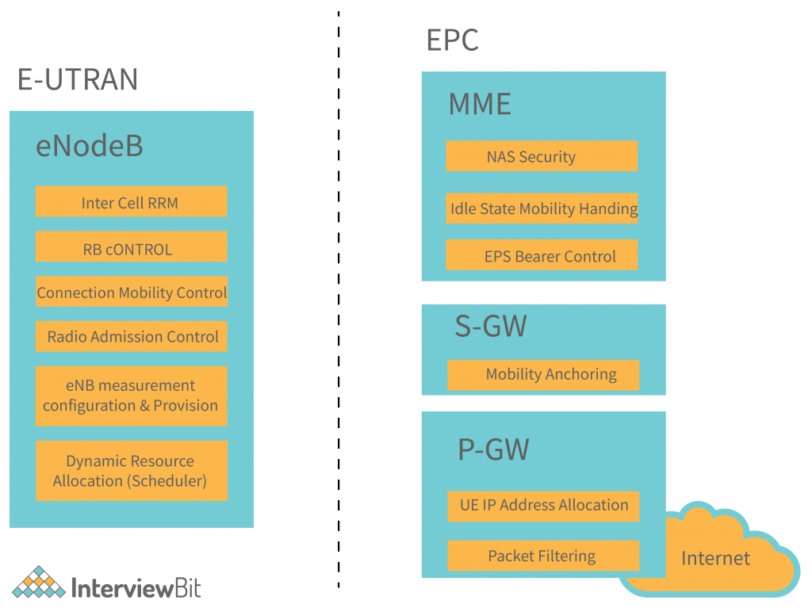

## Advantages of LTE Architecture

LTE technology is highly popular nowadays (2020). This is because of the growing popularity of 4G smartphones that utilise this technology. A high-performance air interface for cellular mobile communication systems has been constructed as part of LTE innovation. The mobile communications system has been improved as a result. It is a fast data network. It is used for improving mobile telephone systems.

1. Data and voice can be exchanged between participants using LTE. Because of packet switching, data and voice can be sent using the same network.
2. Data sent between the sender and receiver can be high amounts.
3. The better life of smartphone batteries is caused by all data exchange being done with very little power consumption.
4. It has fast file upload and download speeds.
5. It reduces the load on the network by releasing network usage faster.
6. Reducing service traffic and favouring fewer crashes is the aim of this initiative.
7. You can watch live shows, matches, and events using LTE.

## Disadvantages of LTE Architecture

4G, also known as long-term evolution, is a fifth generation mobile network. It aims to offer more dependable mobile broadband Internet services such as a mobile device, computer, tablet, or laptop. Because of the fast speed and efficiency of 4G, mobile devices took over the market. To learn more about 4G networks, here is a look at their advantages and disadvantages.

1. Some cities do not have this service.
2. Signals in transit, such as buses and trains, need to be improved by increasing the number of towers and introducing new technologies.
3. The complexity of LTE makes it necessary for competent people to manage the system. They might even need to be paid a higher salary.
4. Old versions of smartphones cannot make use of this technology.
5. The cost of buying new LTE smartphones is high.

## Conclusion

LTE architecture is an evolving standard that will be improved in the future. Although it is still a work in progress, it is promising. The performance qualities of LTE will show improvement as more LTE-enabled devices come on board. The information on this blog can give you a basic understanding of LTE architecture. Apart from that, you can also read other blogs related to LTE.

GSM and HSPA are among the most popular wireless standards for mobile devices and data terminals. They are used to increase capacity and speed by employing a different radio interface with the core network. Long Term Evolution is one of them. Devices that support both GSM and UMTS networks and CDMA 2000 networks can use LTE frequencies and bands in different countries. Multi-band phones are the only ones that can use LTE frequencies and bands in all countries where it is supported

LTE (Long-Term Evolution) architecture, also known as 4G LTE, is designed to provide high-speed data and robust connectivity. The LTE architecture comprises several key components that work together to deliver efficient wireless communication. These components are divided into two main parts: the Evolved Packet Core (EPC) and the Evolved UMTS Terrestrial Radio Access Network (E-UTRAN). Here is an explanation of the different components used in LTE architecture along with a diagram.

### Components of LTE Architecture

1. **User Equipment (UE)**:

- The mobile device used by the end-user to connect to the LTE network. It includes smartphones, tablets, and other LTE-capable devices.

2. **Evolved Node B (eNodeB or eNB)**:

- The base station in LTE that handles radio communication with the UE. It manages the radio resources, performs handovers, and ensures Quality of Service (QoS).

3. **Evolved UMTS Terrestrial Radio Access Network (E-UTRAN)**:

- Comprises multiple eNodeBs that connect to the EPC. E-UTRAN handles the radio interface between the UE and the network.

### Evolved Packet Core (EPC) Components:

4. **Mobility Management Entity (MME)**:

- The control node responsible for handling signaling related to mobility and session management. It manages user authentication, tracks the UE’s location, and controls the establishment of bearers.

5. **Serving Gateway (SGW)**:

- Routes and forwards user data packets. It serves as the local mobility anchor for data bearers during handovers between eNodeBs.

6. **Packet Data Network Gateway (PGW or P-GW)**:

- The gateway that provides connectivity to external packet data networks, such as the internet or corporate intranets. It handles IP address allocation, QoS enforcement, and charging.

7. **Home Subscriber Server (HSS)**:

- A database that contains user-related information, such as subscription data, user profiles, and authentication information.

8. **Policy and Charging Rules Function (PCRF)**:

- Determines the policy control and charging rules. It ensures that the network resources are allocated based on the subscribed services and QoS requirements.

### Supporting Nodes:

9. **evolved Serving Mobile Location Center (eSMLC)**:

- Provides location-based services and geolocation functionalities.

10. **Broadcast Multicast Service Center (BM-SC)**:

- Handles the broadcast and multicast services within the LTE network.

### LTE Architecture Diagram

Here's a simplified diagram of the LTE architecture:

```

+-----------------------------+

| Internet |

+-------------+---------------+

|

+-----+-----+

| P-GW |

+-----+-----+

|

+-----+-----+

| S-GW |

+-----+-----+

|

+-----+-----+

| MME |

+-----+-----+

|

+------------+------------+

| |

+-----+-----+ +-----+-----+

| eNB | | eNB |

+-----+-----+ +-----+-----+

| |

(UE) (UE)

EPC Components: P-GW (Packet Data Network Gateway), S-GW (Serving Gateway), MME (Mobility Management Entity)

E-UTRAN Components: eNB (Evolved Node B), UE (User Equipment)

```

### Explanation of Diagram

- **User Equipment (UE)**: The end-user devices connected to the network via eNodeBs.

- **eNodeB (eNB)**: These base stations communicate with the UE over the air interface and are connected to the EPC.

- **MME**: Manages signaling and control functions, connecting to the eNodeBs and the S-GW.

- **Serving Gateway (S-GW)**: Forwards user data packets and acts as a mobility anchor between eNodeBs.

- **Packet Data Network Gateway (P-GW)**: Connects the LTE network to external data networks like the internet, managing IP allocation and QoS.

This architecture allows LTE networks to deliver high-speed data and efficient connectivity, supporting a wide range of applications and services.

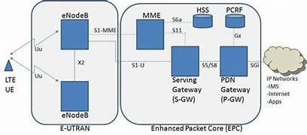

Q. Explain self organising network (SON) for heterogeneous networks 